MASTERS DOCUMENTATION

Application : | NGERP
Workflow : | MASTERS
Workflow Item Name : | Session Audit

Description :

Session Audit Master is Used to monitor the login activity of the user.

Workflow Process :

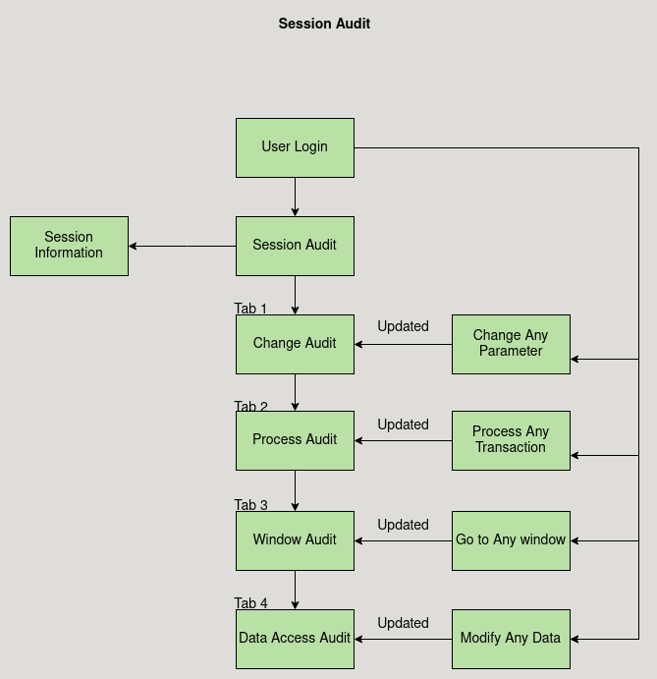

Business Rules :

- Session Audit Master is Used to monitor the login activity of the user.
- It show the information like who logged in, when they logged in, their IP Address, session ID and how much time they have spent in the application on that session.
- There are four tabs in the session audit Master:

  - Change Audit
  - Process Audit
  - Window Audit
  - Data Access Audit

- Change Audit:
This Tab Logs the Changes made in any parameter by showing old value and new value.

- Process Audit:
This Tab Logs all the Transaction made by that user.

- Window Audit:
This Tab Logs all the window the user have visited.

- Data Access Audit:
This Tab Logs the Modification in any parameters.

